Brilliantly presented! Please see my commentary.

100%

**BAE Systems, Inc.**

**03/07/11**

**Concepts of Systems Engineering (SYS501)**

**Mini Systems Engineering Project: Traffic Control System**

**Carlos J. Lazo**

**INTRODUCTION**

The town of Littlecity, USA, has asked for the development of a new traffic control system. Currently, the city has 24 standard traffic lights that guide traffic through the city center. The signals all operate independently and are all of the traditional variety that – they do not have any sensors. Their current programming is to operate purely on a timer.

The goal of this study is to examine the Operational Requirements and then develop a context diagram, concept of operations, concept for candidate solutions, trade study analysis, advanced development effort planning, and analysis of risks for the new traffic control system.

**OPERATIONAL REQUIREMENTS**

The operational requirements for the new traffic control system are as follows:

1) The traffic control system shall sense traffic in the city center.

2) The traffic control system shall connect to each of the traffic signals.

3) The traffic control system shall change timing on the traffic signals to maximize traffic flow through the city.

4) The traffic control system shall provide a way to monitor the status of the traffic in the city.

5) The traffic control system shall provide a way for a user to manually control traffic light settings throughout the city.

6) The traffic control system shall be highly reliable.

7) The traffic control system shall be easy to maintain.

8) The traffic control system shall be cost effective to operate.

9) The traffic control system shall be easy to use.

10) The traffic control system shall use common products and standard products to the maximum extent possible.

**CONTEXT DIAGRAM (Part A)**

A Context Diagram is drawn for the new Traffic Control System, as shown in the picture below:

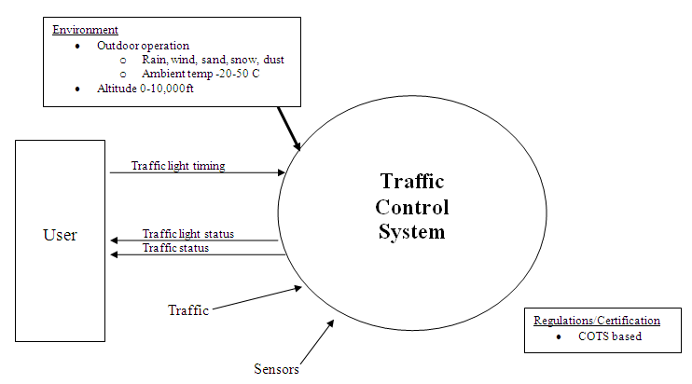

**CONCEPT OF OPERATIONS (Part B)**

The traffic light control system shall have three main objectives – sense the flow of traffic, integrate all traffic lights together, and allow for the user to control and monitor the flow of traffic. In order to sense the flow of traffic, each of the 24 standard traffic lights shall be fitted with sensors which are able to determine the volume of cars present, as well as rate in which cars are traveling at any given time. The state-of-the-art traffic control system will shall use these sensors as the primary input into the processing center for the system. The traffic control system shall be the center of the operation, fusing together information from the 24 standard traffic lights. The networked traffic light system shall fuse an operational environment for the user in real-time through the use of computer software algorithms. The system shall be able to change the traffic light timing at any traffic light, at any time, automatically or through a manual operational mode under user control. Lastly, the traffic environment shall be displayed for a user at a central location in a graphical format. The traffic light control system will be color coordinated and event driven, so the user of the system will be able to easily identify problem areas and react accordingly to the situation.

The system shall use Commercial Off the Shelf (COTS) components, which will allow for an open architecture framework for easy maintainability and reliability. The use of COTS components shall also allow for the system to be upgraded through technology insertions as new software for the system becomes available. The use of these components shall also keep the system at an affordable price for the end user and allow for additional sensors/traffic lights to be added to the control system not only affordably, but through an easier integration period.

**CONCEPTUAL SOLUTIONS FOR TRAFFIC CONTROL SYSTEM (Part C)**

The following are two conceptual solutions for the new traffic control system:

**Candidate System 1** *–* **IRTLCS** (**I**nfra**R**ed **T**raffic **L**ight **C**ontrol **S**ystem)

Candidate System 1 will go by the name **I**nfra**R**ed **T**raffic **L**ight **C**ontrol **S**ystem (**IRTLCS**). The system will be a start-of-the-art, networked, real-time traffic light control system which will provide the latest in sensor fusion, data processing, and situational monitoring to exceed user requirements.

The basic concept is that sensors collect data, process the data at a processing station local to the sensor, and continuously create a sensor report which is then sent over a wireless protocol to the data processing center. At the data processing center, all sensor reports from all traffic lights are fused together to create the traffic light situational awareness at the current time. Through the use of advanced software algorithms, the traffic lights may be controlled autonomously or through manual user input.

The sensors will passive IR based. The sensor will be an adjunct to the traffic light and will not constrict the flow of traffic in any way. It will scan the intersection through a top down approach. The sensor will determine how many vehicles are in its field of vision, and will then send data to the local sensor processing station. The figures below details sensor placement and operation:

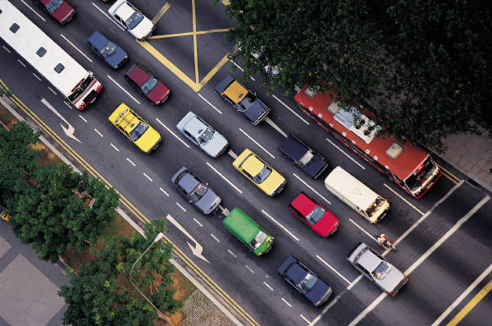

Sensor scans section at intersection

Local sensor processing station



**IR System**

The following is a notional block diagram for the system:

Sensors

Local sensor report processor

Wireless  
Transmitter

Wireless

Receiver

Sensor report

processor

Sensor fusion

Decision   
Processor

Display

**Traffic Light:**

**Data Processing Center:**

The IRTLCS passive adjunct sensor concept will provide the latest in technology to Littlecity, USA. It will minimize the amount of infrastructure support needed to connect each traffic light to the data processing station and will not need any construction to embed sensors in the ground. IRTLCS will give Littlecity the ability to operate their streets safer and more efficiently.

**Candidate System 2** *–* **VBTLCS** (**V**ision **B**ased **T**raffic **L**ight **C**ontrol **S**ystem)

Candidate System 2 will go by the name **V**ision **B**ased **T**raffic **L**ight **C**ontrol **S**ystem (**VBTLCS**). The system will implement production-line proven technology, networked traffic lights, and real-time traffic processing to exceed user requirements. Vision systems have been a staple of the manufacturing industry and are highly mature technology which can monitor the flow of manufactured parts and check them for tolerances with great ease. They will be the foundation of this candidate system.

The basic concept is that vision systems will be placed at each major intersection where traffic lights are present. These vision systems are able to see the volume of traffic in real-time and send this data (and video) to a centralized data processing center. At the data processing center, all video feeds are then fed into image/video recognition software which will use advanced computer algorithms to process the traffic present and then fuse a quantifiable situational awareness to the user. The traffic lights may be controlled automatically or through a manual user control input at any time.

The sensors will vision based. The sensor will be an adjunct to the traffic light and will not constrict the flow of traffic in any way. It will scan the intersection through a top down approach. The sensor will simply record the video, and send it real-time to the data processing center. The figures below details sensor placement and operation:



Vision system scans section at intersection



**Vision System**



The following is a notional block diagram for system:

Vision System

Wireless  
Transmitter

Wireless

Receiver

Video Processor

Data fusion

Decision   
Processor

Display

**Traffic Light:**

**Data Processing Center:**

The VBTLCS passive adjunct sensor concept will provide the latest in technology to Littlecity, USA. It will minimize the amount of infrastructure support needed to connect each traffic light to the data processing station and will not need any construction to embed sensors in the ground. VBTLCS will give Littlecity the ability to operate their streets safer and more efficiently.

**TRADE STUDY (Part D)**

The decision criteria that would be selected for a trade study would be the following:

* **Cost**
  + Operational Requirement for a cost effective solution.
* **Reliability** (**MBTF**) **and Safety**
  + Operational Requirement for reliable and safe system.
* **Risk** 
  + A factor which is present in every decision.
* **Size, Weight, and Power (SWAP)**
  + Based on the infrastructure available, these are all limitations for the system at the traffic light. In the situation that a system needs a lot of power to operate, then this factor needs to be taken into account.
* **Schedule** 
  + Even though it wasn’t directly specified from the user that they need the system quickly, this criteria will assist in the decision making.
* **Integrated Solution**
  + Each traffic light needs to be integrated into the system. The criterion would gauge how well this integration can be achieved.

A table listing each individual criterion, allocated weighting, and reason for weighting is listed below:

| **Criterion** | **Weight (%)** | **Justification/Reason for Weight** |
| --- | --- | --- |
| **Cost** | **25 %** | Cost is an operational requirement. The town of “Littlecity” is just that – small, and has a limited budget. The city only has 24 traffic lights; to put it into perspective, New York City has roughly 80,000. This item is weighted the most because Littlecity needs a cost effective solution. |
| **Reliability (MTBF)**  **and**  **Safety** | **20 %** | This is also an operational requirement for the system. Given the anticipated limited budget for procurement of the system, Littlecity would also need to have a system which is highly reliable.  In addition, any system which is used near or around humans regularly must take into account safety. Redundancy procedures, fail safe mechanisms, etc. will need to be a part of any design for the traffic light system. |
| **Risk** | **20 %** | This is a very important factor to have in the selection process. Managing the risk of a potential system will be key in determining which system to go forth for the final design. Systems Engineering must take into account schedule, personal, and technical risk. This is why this weighting is high. |
| **Size,**  **Weight,**  **and Power**  **(SWAP)** | **15%** | The SWAP of the system is a very important factor when deciding which design to use. Each implementation will have their own tradeoffs between these three components, and all must be weighted given the constraints that limit each individual system concept. In many instances, system SWAP is a key component of the decision-making process. |
| **Schedule** | **10 %** | Even though schedule is not a part of the listed operational requirements and Littlecity has not expressed a time constraint, schedule is a factor that will always be factored into a design solution because no user has an unlimited timeline to have the system delivered. |
| **Integrated**  **Solution** | **10 %** | This measure is a metric for whether the solution is integrated, based on the operational requirement for the system to have a connection to each traffic light. |

**ADVANCED DEVELOPMENT PHASE AND RISKS FOR PROPOSED SOLUTION (Part E)**

**Candidate System 2**, **VBTLCS**, will be chosen and used for the discussion on the Advanced Development phase for the program. The focus of this Advanced Development Effort will be primarily for risk reduction. It will prove that basic system concept is feasible, and that the areas where the risk is the highest have been researched and investigated with much detail. The output of this phase will be a demonstration system, and it will be integrated into 1 traffic light in the town of Littlecity.

The Advanced Development Effort will focus on creating a demonstration system to validate the system design and the concept of operation. Each risk reduction activity will be focused on developing a proof of concept and not a highly matured, integrated solution. For example, the display created during this Effort will be extremely limited and will not take into account the Human Factors needs of the end user. As mentioned, the goal of this phase is prove to the Littlecity Source Selection Board (LSSB) that this system can and will work when they take delivery through a demonstration.

In order to outline the Advanced Development Effort, the highest risk items for the system will be identified through the use of the block diagram. In the figure below, all items highlighted in blue represent the items of highest risk. Arrows represent interfacing mechanisms and the boxes represent the individual subsystems of the overall system concept:

Vision System

Wireless  
Transmitter

Wireless

Receiver

Video Processor

Data fusion

Decision   
Processor

Display

**Traffic Light:**

**Data Processing Center:**

The focus of the effort will be performed in the following key areas.

* Interface between the Vision System and a Wireless Transmitter
* Interface between the Wireless Receiver and Video Processor
* Video Processor subsystem
* Data fusion subsystem
* Decision Processor

*Interface between Vision System and Wireless Transmitter*

This has been selected because Vision Systems and Wireless Transmitters are readily available as COTS components; however, the interaction between these two subsystems will need further development and is a risk issue if it cannot be proven early on in the Advanced Development Effort.

*Interface between the Wireless Receiver and Video Processor*

After the Wireless Receiver subsystem has received the data stream from the Wireless Transmitter sub system, it must interact with the Video Processor subsystem so that the raw video is processed through image/video processing algorithms. The Wireless Receiver’s interface will be standardized for an output format for streaming video, but the interface to the Video Processor sub system will need to be researched in further detail.

*Video Processor Subsystem*

This software, which may be included in the Vision System, will need development in order to perform the image processing which the system requires. It will also need to output the situational report in a standardized format for the Data Fusion sub system to use.

*Data Fusion Subsystem*

This subsystem is responsible for fusing together situational reports from each traffic light in Littlecity.

*Decision Processor Subsystem*

This subsystem is responsible for determining which traffic lights need shorter/longer durations and where the heaviest flow of traffic is in the city. It will send these to a Display subsystem, which will not be a focus of this effort.

A detailed list denoting 10 programmatic/technical risks, ranked in priority order, is seen below. Provided with each is a plan which may be exercised in order to mitigate that specific risk:

| Priority | Risk | Mitigation Plan |
| --- | --- | --- |
| 1 | Technical solution unfeasible | The Advanced Development Effort should address highest risk issues to reduce overall program risk. Ranking the highest risk items, putting up front company investment/emphasis on these items will help to solve the problems addressed down the road when Engineering says “this just cannot work.” |
| 2 | Schedule becomes a Key Performance Parameter for Customer | This is a big risk issue. If schedule does become a key driver when the official specification is released or at an Industry Day, it could blind side the program. Having Business Development (BD) and Engineering investigating this key item early and often, along with double checking that Schedule is not a key driver, has to happen at all times. |
| 3 | Size, weight, power become a Key Performance Parameter and current solution is unable to support strict Customer Requirements | BD and Systems Engineering need to be connected with the Customer’s key drivers and ensure that SWAP are not critical to them upfront. They will release a Draft/Final Specification, at which time Systems Engineering may be able to look at the requirements and see if they are obtainable. However, having an intimate relationship with the Customer will keep Engineering informed as to what the Key Performance Parameters (KPPs) are from the beginning. Engineering must be able to meet these, and being blindsided by requirements that are very strict/out of scope should never be an issue. |
| 4 | Cost for system is too high for Customer procurement | BD and Engineering must know early the amount of budget available for procurement of this system. At no time should the Price to Win be a surprise for the capture/program team. Addressing the areas where the cost will be the highest – such as high value components or man-hours. Use of IRADs for development activities in advance of program will be a factor to the program’s success. |
| 5 | Customer Buy In for Full Development Phase | Business Development team must be intimate with Customer about understanding their key drivers. Systems Engineering must help BD pitch the technical solution during Technical Interchange Meetings (TIM). |
| 6 | Company unable to support IRAD for risk reduction on program | In some instances, IRADs to support programs are thrown away for major business captures and smaller programs suffer. If an IRAD is unsupported by the company through the Advanced Development Effort, Systems Engineering will have to be honest with the Customer about addressing risk and maturity of the technology. Mitigation plan will be to build in more research and development in to the full program or have a demonstration at Preliminary Design Review of the system in order to build trust with the Customer. There’s not a whole lot Systems Engineering could do to mitigate it, except for lobbying for this IRAD to Senior Management when the funding of IRADs are examined. |
| 7 | Customer unable to support demonstration on traffic light in city | After testing in a System Integration Lab, getting time on the “platform” is vital to the program’s success. Engineering must work with Customer to explain schedule, motive, and goals for using a real traffic light system. Research should be done upfront during planning for a backup testing on a traffic light – such an example would be a parking lot simulation. |
| 8 | Key components unavailable   for purchase | Identify and research all key components during Advanced Development Effort. Establish ties with vendors/manufacturers early on in order to make deadline. |
| 9 | Subject Matter Experts (SMEs) unavailable to support program | Senior Engineers with experience are always in demand – however, addressing a Director of Engineering early and expressing the timeline, requirements for program will help secure key SMEs. |
| 10 | Staffing needs are unmet by company due to other programs | This is a standard problem at a large company (for example, BAE Systems). The staffing managers need to be aware of the program’s timelines early and the Systems Engineering team should identify the people/skill sets that are needed for the program to be successful. Someone with networking experience, software integration and development, vision system experience, testing, planning, scheduling, etc. are all areas which need to be addressed. |